**Weather Forecast website**

### **A MINI PROJECT REPORT**

#### **Submitted by**

#### 

#### **Group/Team No: G4/T25**

Gaurav Thakur (2310990335)

Gautam Jain (2310990336)

Gopesh Goyal (2310990337)

#### ***in partial fulfillment for the award of the degree of***

## **BACHELEOR OF ENGINEERING**

***in***

COMPUTER SCIENCE & ENGINEERING



**CHITKARA UNIVERSITY**

**CHANDIGARH-PATIALA NATIONAL HIGHWAY**

**RAJPURA (PATIALA) PUNJAB-140401 (INDIA)**

2023-2027

**TABLE OF CONTENT**

###### 

|  |  |  |
| --- | --- | --- |
| TOPIC | Section | Page no |
| INTRODUCTION | 1 | 3 |
| PROBLEM STATEMENT | 2 | 4 |
| TECHNICAL DETAILS | 3 | 5 |
| KEY FEATURES | 4 | 6 |
| PROJECT HIGHLIGHTS | 5 | 7 |
| RESULT | 6 | 11 |
| CONCLUSION | 7 | 12 |
| REFERENCE LINK | 8 | 13 |

**Introduction**

**Project purpose:**

The purpose of a project for weather forecasting is to provide accurate and timely information about current and future weather conditions.

**Project Goal:**

**Accuracy:** Provide precise and reliable predictions of weather conditions.  
  
**Safety:** offer early warnings for severe weather events to protect lives and property.  
  
**Communication:** effectively convey weather information to the public and various sectors.

**Problem Statement**

**Complexity of the atmosphere:** weather forecasting deals with a highly complex and dynamic atmosphere. The atmosphere is influenced by numerous factors, including temperature, pressure, humidity, wind patterns, and the interaction of various air masses. Predicting how all these factors will interact accurately can be challenging.  
  
**Limited data availability:** weather forecasts heavily rely on accurate and up-to-date data from various sources, such as weather stations, satellites, and weather balloons. Gaps in data collection, inaccurate measurements, or data delays can lead to less precise forecasts.  
  
**Modeling errors:** numerical weather prediction models are used to simulate the behavior of the atmosphere. These models have limitations and can introduce errors, especially in long-range forecasts. Fine-tuning models to match observed conditions is an ongoing challenge.  
  
 **Xtreme weather event's:** predicting the path and intensity of extreme weather events like hurricanes, tornadoes, and flash floods can be particularly challenging due to their rapid development and complex dynamics.

**Technical Detail's**

1. Vs code as a code editor has been used.

2. Html 5 and css is used in this project.

3. External css is used for the easy learning of code.

4. Compressed images/favicon for the better user interference

**Key Features**

**Current weather data:** provide real-time data on current weather conditions, including temperature, humidity, wind speed and direction, atmospheric pressure, and precipitation levels. Users should have access to the most up-to-date information.  
  
**Short-term forecasts:** offer short-term weather forecasts for the next few hours or days. This includes predictions for temperature changes, precipitation, and wind conditions to help users plan their immediate activities.  
  
**Long-term forecasts:** include longer-range forecasts, typically covering a week or more. These forecasts give users an idea of what to expect in terms of weather trends, enabling them to plan vacations, events, or outdoor activities.  
  
**Severe weather alerts:** implement a system for issuing severe weather alerts, such as warnings for hurricanes, tornadoes, floods, or extreme heat. Users should receive notifications about potential threats in their area.

**Project Highlight**

**HTML :**

CSS :

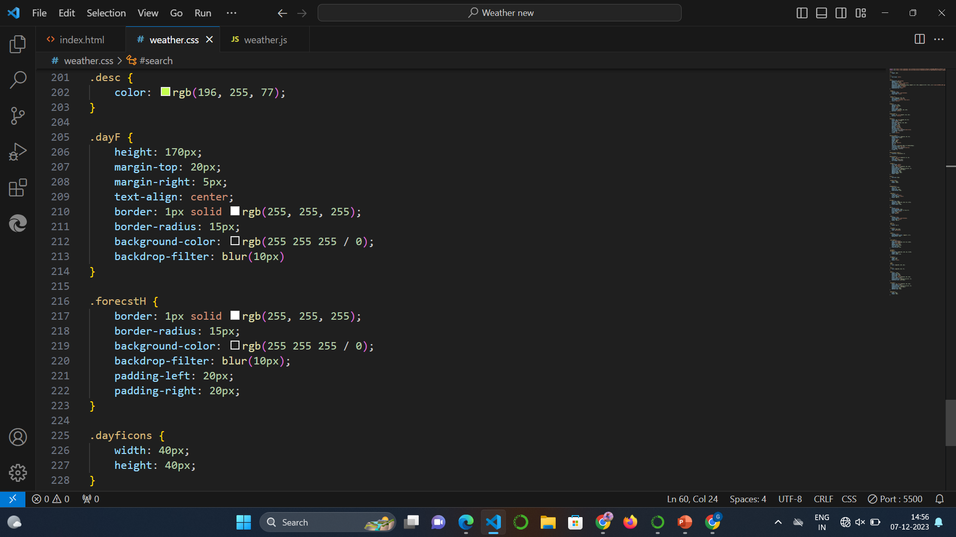

JAVASCRIPT:

**Result**

**Conclusion**

1.This project is all about providing the user right information and critics about the various topics.  
  
2. This project desire to inspire the humans for the various activism activity and stand with or against them as need.  
  
3. The creative user interference of this webpage will help user to navigate them into the desire topic with more ease and pleasing.

**Reference link**

1. HTTPS://WWW.W3SCHOOLS.COM/  
2. MDN.COM  
3. HTTPS://WWW.YOUTUBE.COM/

**Thank You**